EXP.NO.2

WRITE A JAVASCRIPT PROGRAM TO VALIDATE THE
FOLLOWING FIELDS OF THE HTML REGISTRATION PAGE

AIM:
To write JavaScript code to validate user input in a registration form. The validation will ensure that the data entered by the user meets specific criteria for each field. This will help in maintaining data integrity and prevent invalid submissions
ALGORITHM:
A) Input:
- The user fills in the following fields: First Name, Password, E-mail, Mobile Number, Last Name, and Address.

B) Validation Steps:
1. Validate First Name:
- Check if the first name contains only alphabets.
- Ensure the length of the First Name is at least 6 characters.
- If any of these conditions fail, display an error message indicating the required input.
2. Validate Password:
- Check if the password is at least 6 characters long.
- If it is less than 6 characters, display an error message.
3. Validate E-mail:
Use a regular expression to check if the email follows the standard pattern:
- name@domain.com.
- Ensure that the email contains no invalid characters and matches the required
- pattern.
- If it doesn’t match, display an error message indicating an invalid email
- format.
4. Validate Mobile Number:
- Check if the mobile number contains exactly 10 digits.
- Ensure there are no alphabets or special characters.
- If the number is invalid, display an error message indicating the correct format.
5. Validate Last Name:
- Ensure the Last Name field is not empty.
- If it is empty, display an error message.

6. Validate Address:
- Ensure the Address field is not empty.
- If it is empty, display an error message.

CODE:

login.html :
<!DOCTYPE html>
<html>
<head>
<title>Online Feedback System</title>

<script>
function validateForm() {

var fname = document.myform.fname.value;
var lname = document.myform.lname.value;
var pass = document.myform.pass.value;
var email = document.myform.email.value;
var mobile = document.myform.mobile.value;
var address = document.myform.address.value;

var namePattern = /^[A-Za-z]+$/;
var emailPattern = /^[^ ]+@[^ ]+\.[a-z]{2,3}$/;
var mobilePattern = /^[0-9]{10}$/;

if(fname.length < 6 || !fname.match(namePattern)){
alert("First name must contain alphabets and minimum 6 letters");
return false;
}

if(pass.length < 6){
alert("Password must be minimum 6 characters");
return false;
}

if(!email.match(emailPattern)){
alert("Invalid Email");
return false;
}

if(!mobile.match(mobilePattern)){
alert("Mobile number must contain 10 digits");
return false;
}

if(lname == "" || address == ""){
alert("Last name and Address should not be empty");
return false;
}

alert("Feedback Submitted Successfully");
return true;
}
</script>
</head>

<body>

<h2 align="center">Online Feedback Collection System</h2>

<form name="myform" onsubmit="return validateForm()">

First Name:
<input type="text" name="fname"><br><br>
Last Name:
<input type="text" name="lname"><br><br>
Password:
<input type="password" name="pass"><br><br>
Email:
<input type="text" name="email"><br><br>
Mobile Number:
<input type="text" name="mobile"><br><br>
Address:
<textarea name="address"></textarea><br><br>
Feedback:
<textarea></textarea><br><br>

<input type="submit" value="Submit">

</form>

</body>
</html>

OUTPUT:

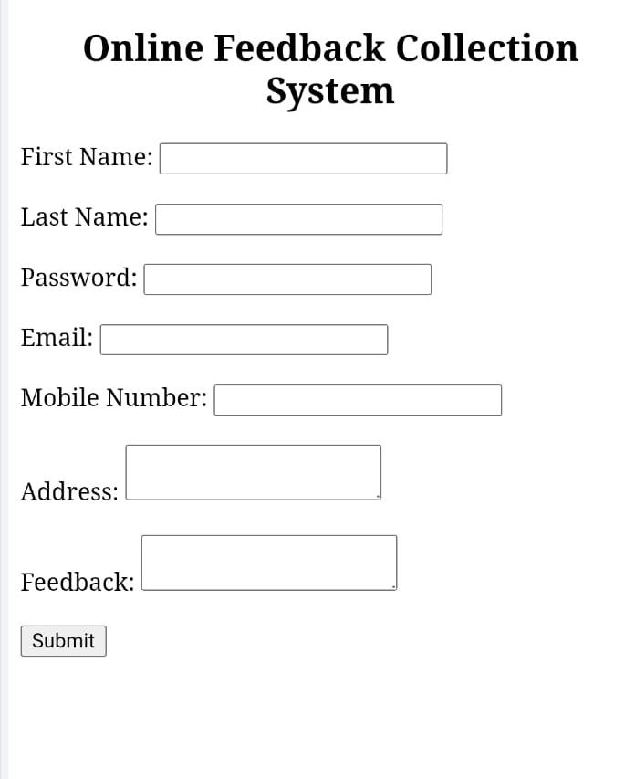

RESULT:
HTML page with Form is created and is validated using Javascript

